Communications for all in East Africa
3rd EACO WRC-23 preparatory meeting (17th-19th/08/2021)
CHAPTER 3 (Science issues)
Input Document
Agenda Item 1.12
Part A: Description
to conduct, and complete in time for WRC 23, studies for a possible new secondary allocation to the Earth exploration-satellite (active) service for spaceborne radar sounders within the range of frequencies around 45 MHz, taking into account the protection of incumbent services, including in adjacent bands, in accordance with Resolution 656 (Rev. WRC 19);

Resolution 656 (Rev. WRC 19) - Possible secondary allocation to the Earth exploration-satellite service (active) for spaceborne radar sounders in the range of frequencies around 45 MHz.
Part B: Key Elements – the notables
This agenda item seeks a new secondary allocation to the Earth exploration-satellite (EESS) (active) service for spaceborne radar sounders within a range of frequencies around 45 MHz while considering the protection of incumbent services including those in adjacent bands.
The following are the notables in respect to this Agenda Item;
- There is an interest in using active spaceborne sensors in the vicinity of the frequency range 40-50 MHz for measurements of the Earth’s subsurface to provide radar maps of subsurface scattering layers with the intent to locate water/ice/fossil deposits.
- The active spaceborne sensors can provide unique information on physical properties of the Earth and other planets and require specific frequency ranges depending on the physical phenomena to be observed.
Therefore;
A secondary allocation for EESS (active) in the 40-50 MHz frequency range will enable the operation of a scientific mission that will produce sub-surface data with a vertical resolution of 5-7 m.
The mission’s scientific objectives are:
- to understand the global thickness, inner structure, and the thermal stability of the Earth’s ice sheets (e.g. in Greenland and Antarctica-see fig 1) as an observable parameter of Earth climate evolution, and
- to understand the occurrence, distribution, and dynamics of the Earth fossil aquifers in desert environments such as those in northern Africa (see fig 1) and the Arabian Peninsula as key elements in understanding recent paleoclimatic changes.
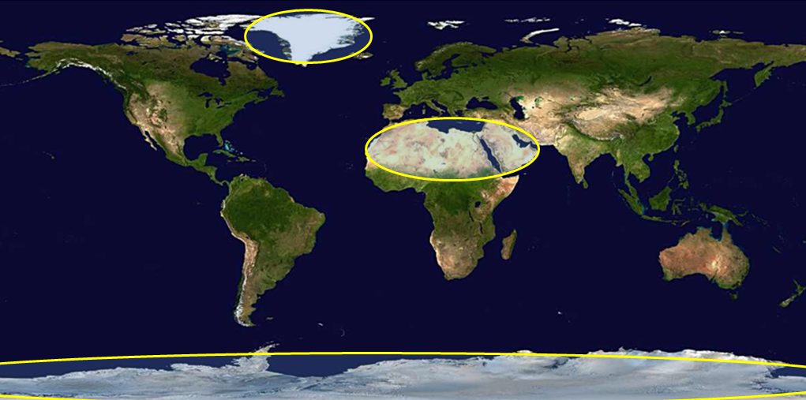
Figure 1: Coverage area for Spaceborne radar sounders (yellow circles)

Part C: Current Status of Band
Part A: RR Article 5

Provides the following in terms of the international frequency allocation of the frequency band 40-50 MHz and adjacent bands.

Allocation to services
Region 1 | Region 2 | Region 3
24 990-25 005 STANDARD FREQUENCY AND TIME SIGNAL (25 000 kHz)
25 005-25 010 STANDARD FREQUENCY AND TIME SIGNAL
Space research
25 010-25 070 FIXED
MOBILE except aeronautical mobile
25 070-25 210 MARITIME MOBILE
25 210-25 550 FIXED
MOBILE except aeronautical mobile
25 550-25 670 RADIO ASTRONOMY
5.149
25 670-26 100 BROADCASTING
26 100-26 175 MARITIME MOBILE 5.132
26 175-26 200 FIXED
26 200-26 350  FIXED  MOBILE except aeronautical  mobile  Radiolocation 5.132A  5.133A | 26 200-26 420  FIXED  MOBILE except aeronautical  mobile  RADIOLOCATION 5.132A | 26 200-26 350  FIXED  MOBILE except aeronautical  mobile  Radiolocation 5.132A
26 350-27 500  FIXED  MOBILE except aeronautical  Mobile  5.150 |  | 26 350-27 500FIXED  MOBILE except aeronautical  mobile  5.150
26 420-27 500
FIXED
MOBILE except aeronautical
mobile
5.150
27.5-28 METEOROLOGICAL AIDS
FIXED
MOBILE
28-29.7 AMATEUR
AMATEUR-SATELLITE
29.7-30.005 FIXED
MOBILE
30.005-30.01 SPACE OPERATION (satellite identification)
FIXED
MOBILE
SPACE RESEARCH
30.01-37.5 FIXED
MOBILE
37.5-38.25 FIXED
MOBILE
Radio astronomy
5.149
38.25-39  FIXED  MOBILE | 38.25-39.986  FIXED  MOBILE | 38.25-39.5  FIXED  MOBILE
39-39.5
FIXED
MOBILE
Radiolocation 5.132A
5.159
39.5-39.986  FIXED  MOBILE |  | 39.5-39.986  FIXED  MOBILE  RADIOLOCATION 5.132A
39.986-40.02  FIXED  MOBILE  Space research |  | 39.986-40  FIXED  MOBILE  RADIOLOCATION 5.132A  Space research
40-40.02
FIXED
MOBILE
Space research
40.02-40.98 FIXED
MOBILE
5.150
40.98-41.015 FIXED
MOBILE
Space research
5.160 5.161
41.015-42 FIXED
MOBILE
5.160 5.161 5.161A
42-42.5  FIXED  MOBILE  Radiolocation 5.132A  5.160 5.161B | 42-42.5  FIXED  MOBILE  5.161
44-47 FIXED
MOBILE
5.162 5.162A
47-50  BROADCASTING  5.162A 5.163 5.164 5.165 | 47-50  FIXED  MOBILE | 47-50  FIXED  MOBILE  BROADCASTING  5.162A
50-52  BROADCASTING  Amateur 5.166A 5.166B 5.166C  5.166D 5.166E 5.169 5.169A  5.169B  5.162A 5.164 5.165 | 50-54  AMATEUR  52-68 5.162A 5.167 5.167A 5.168 5.170
52-68
BROADCASTING

5.162A 5.163 5.164 5.165
5.169 5.169A 5.169B 5.171
 | 54-68  BROADCASTING  Fixed  Mobile  5.172 | 54-68  FIXED  MOBILE  BROADCASTING  5.162A

Part B: African common allocations and typical applications as per AfriSAP

AfriSAP provides the following in terms of the African common allocations and typical utilizations for the frequency range 40 – 50MHz and adjacent bands.

ITU Region 1 Allocation and footnotes | African Common Allocation (s) and footnotes | Typical Application
24 990-25 005 kHz  STANDARD FREQUENCY AND TIME SIGNAL (25 000 kHz) | 24 990-25 005 kHz  STANDARD FREQUENCY AND TIME SIGNAL (25 000 kHz)
25 005-25 010 kHz  STANDARD FREQUENCY AND TIME SIGNAL  Space research | 25 005-25 010 kHz  STANDARD FREQUENCY AND TIME SIGNAL  Space research
25 010-25 070 kHz  FIXED  MOBILE except aeronautical mobile | 25 010-25 070 kHz  FIXED  MOBILE except aeronautical mobile | Fixed and Mobile applications
25 070-25 210 kHz  MARITIME MOBILE | 25 070-25 210 kHz  MARITIME MOBILE | Maritime applications
25 210-25 550 kHz  FIXED  MOBILE except aeronautical mobile | 25 210-25 550 kHz  FIXED  MOBILE except aeronautical mobile | Fixed and Mobile Applications
25 550-25 670 kHz  RADIO ASTRONOMY  5.149 | 25 550-25 670 kHz  RADIO ASTRONOMY  5.149 | Radio Astronomy (Observations of decametric radiation)
25 670-26 100 kHz  BROADCASTING | 25 670-26 100 kHz  BROADCASTING | HF Sound Broadcasting
26 100-26 175 kHz  MARITIME MOBILE 5.132 | 26 100-26 175 kHz  MARITIME MOBILE 5.132 | Maritime applications
26 175-26200 kHz  FIXED  MOBILE except aeronautical mobile | 26 175-26 200 kHz  FIXED  MOBILE except aeronautical mobile | Fixed Applications  Mobile systems (single frequency)  CB Radio (26.96-27.410 MHz)
26 200-26 350 kHz  FIXED  MOBILE except aeronautical mobile  Radiolocation 5.132A | 26 200-26 350 kHz  FIXED  MOBILE except aeronautical mobile  Radiolocation 5.132A | Fixed and mobile applications
26 350-27 500 kHz  FIXED  MOBILE except aeronautical mobile  5.150 | 26 350-27 500 kHz  FIXED  MOBILE except aeronautical mobile  5.150 | Fixed and mobile applications  Inductive/non-specific SRD applications (26 957-27 283 kHz):  - Wireless control devices  Measurement equipment
27.5-28 MHz  METEOROLOGICAL AIDS  FIXED  MOBILE | 27.5-28 MHz  METEOROLOGICAL AIDS  FIXED  MOBILE | Fixed and mobile applications  Meteorological applications
28-29.7 MHz  AMATEUR  AMATEUR-SATELLITE | 28-29.7 MHz  AMATEUR  AMATEUR-SATELLITE | Amateur communications  Amateur-satellite communications
29.7-30.005 MHz  FIXED  MOBILE | 29.7-30.005 MHz  FIXED  MOBILE | Fixed Applications
30.005-30.01 MHz  SPACE OPERATION (satellite identification)  FIXED  MOBILE  SPACE RESEARCH | 30.005-30.01 MHz  SPACE OPERATION (satellite identification)  FIXED  MOBILE  SPACE RESEARCH
30.01-37.5 MHz  FIXED  MOBILE | 30.01-37.5 MHz  FIXED  MOBILE | Fixed and mobile applications  Private Mobile Radio (walkie talkies)
37.5-38.25 MHz  FIXED  MOBILE  Radio astronomy  5.149 | 37.5-38.25 MHz  FIXED  MOBILE  Radio astronomy  5.149 | Private Mobile Radio (walkie talkies)  Radio Astronomy (Observations of decametric radiation)
38.25-39 MHz  FIXED  MOBILE | 38.25-39 MHz  FIXED  MOBILE | Private Mobile Radio (walkie talkies)  Mobile applications
39-39.5 MHz  FIXED  MOBILE  Radiolocation 5.132A  5.159 | 39-39.5 MHz  FIXED  MOBILE  Radiolocation 5.132A | Mobile applications
39.5-39.986 MHz  FIXED  MOBILE | 39.5-39.986 MHz  FIXED  MOBILE
39.986-40.02 MHz  FIXED  MOBILE  Space research | 39.986-40.02 MHz  FIXED  MOBILE  Space research | Private Mobile Radio (walkie talkies)
40.02-40.98 MHz  FIXED  MOBILE  5.150 | 40.02-40.98 MHz  FIXED  MOBILE  5.150 | Private Mobile Radio (walkie talkies)  Fixed applications  SRD (40.66 – 40.7 MHz):  - Radio Microphone  - Wireless control devices  Measurement equipment
40.98-41.015 MHz  FIXED  MOBILE  Space research  5.160 5.161 | 40.98-41.015 MHz  FIXED  MOBILE  Space research  5.160[AddA4] | Private Mobile Radio (walkie talkies)
41.015-42MHz  FIXED  MOBILE  5.160 5.161 | 41.015-42 MHz  FIXED  MOBILE  5.160[AddA4] | Private Mobile Radio (walkie talkies)  Fixed Applications
42-42.5 MHz  FIXED  MOBILE  Radiolocation 5.132A  5.160 5.161B | 42-42.5 MHz  FIXED  MOBILE  Radiolocation 5.132A  5.160[AddA4]
42.5-44 MHz  FIXED  MOBILE  5.160 5.161 5.161A | 42.5-44 MHz  FIXED  MOBILE  5.160[AddA4] | Fixed and mobile applications
44-47 MHz  FIXED  MOBILE  5.162 5.162A | 44-47 MHz  FIXED  MOBILE | Private Mobile Radio (walkie talkies)  Meteor Burst (45.3-46.9 MHz)
47-50 MHz  BROADCASTING  5.162A 5.163 5.164 5.165 | 47-50 MHz  BROADCASTING  5.164[AddA14] 5.165 [AddA12] | Private Mobile Radio (walkie talkies)  Meteor Burst (47.5-49.1 MHz)  Broadcasting systems
50-52 MHz  BROADCASTING  Amateur 5.166A 5.166B 5.166C 5.166D 5.166E 5.169 5.169A 5.169B  5.162A 5.164 5.165 | 50-52 MHz  BROADCASTING  Amateur 5.166B 5.166C 5.169[AltA10] 5.169A[AltA10] 5.169B[UseL5]  5.164[AddA14] 5.165 | Broadcasting systems
52-68 MHz  BROADCASTING  5.162A 5.163 5.164 5.165  5.169 5.169A 5.169B 5.171 | 52-68 MHz  BROADCASTING  5.164[AddA14] 5.165 [AddA12] 5.169[AltA10] 5.169A[AltA10] 5.169B[UseL5] 5.171[AddA11] | Broadcasting systems

To satisfy the requirements/invite of RES 656 (Rev. WRC 19), WP 7C responsible for the AI considered services within a frequency range ± 15MHz from the frequency 45MHz. Table 1 below lists incumbent services that could be impacted.

Services | Frequency band (MHz)
 | 25-40 | 40-50 | 50-65
Standard Frequency and Time | [24.99-25.005]
 |  | 39.986-40.02
Fixed | [25.01-25.07] | 37.5-50 | [68-74.8]
 | [25.21-25.33]
 | [26.175-28]
 | [29.7-30.005]
 | [37.5-38.02]
 | [38.25-39.986]
Mobile | [25.01-25.07] | 37.5-50 | [68-74.8]
 | [25.21-25.33]
 | [27.5-28]
 | [29.7-30.006]
Maritime Mobile | [25.07-25.21] | 44-47
 | [26.1-26.175]
Radio Astronomy | [25.55-25.67]
 | 37.5-38.25
Broadcasting | [25.67-26.1] | 47-50 | [50-68]
 |  |  | [68-72]
Meteorological Aids | [27.5-28]
Amateur/Amateur Satellite | [28-29.7] |  | 50-54
Space Research |  | 39.986-40.02
 |  | 40.98-41.015
Radiolocation |  | 39.986-40.02 | [54-68]
 |  | 42-42.5 | [68-72]
 |  | 41-44¹
 |  | 41.015-41.665²
 |  | 43.35-44²
 |  | 46-68³
¹ Radio Regulations (RR) 5.161 allocates the radiolocation service (RLS) in the 41-44 MHz band in Iran (Islamic Republic of) and Japan on a secondary basis.
² RR 5.161A allocates the 41.015-41.665 MHz and 43.35-44 MHz bands to the RLS on a primary basis in Korea (Rep. of) and the Unites States.
³ RR 5.162A allocates the 46-68 MHz band to the RLS on a secondary basis to 32 countries.

Part D: Conclusion of the results of studies, if any
Compatibility studies between the radar sounders and incumbent services operating in the 40-50 MHz frequency band are yet to be completed. However, the following have preliminarily been established.

- PDR ITU-R RS 2455-1, which among others highlights

- spaceborne radar sounders operational characteristics based on description in ITU-R RS 2042,
- two study analysis methodologies.
- Static methodology and,
- Dynamic methodology
- typical emission spectrum mask for radar sounders operating in the range 40-50 MHz
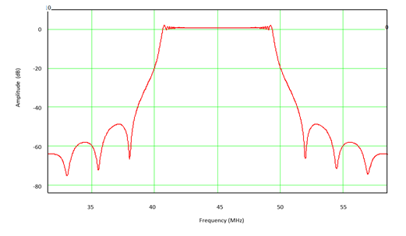
Figure 2: Chirp Emission Spectrum

- The typical operation time of radar sounders, i.e. local hours of 3 a.m. to 6 a.m
- Pfd and spectral pfd levels on the earth’s service;
- power flux-density (pfd) of −93.3 dB(W/m2) at 45 MHz at the surface of the Earth,
- spectral pfd of -163.3 dB(W/m²-Hz) at 45MHz
- service protection criteria whereby maximum interference levels for incumbent services within the 40-50MHz frequency band are highlighted (see table 2 below)

Service | I/N  (dB) | Channel  bandwidth (kHz) | Maximum interference level (dBW/channel bandwidth)
Fixed | −6 | 36 | −141.4
Mobile | −10 | 16 | −148.9
Broadcasting | −10 | 9* | −151.4
Space Research | −6 | 1 | −157
Radiolocation | −6 | 125 | −136
* The appropriate value for channel bandwidth used in the calculations for the Broadcasting service needs further investigation. Information from ITU-R Recommendations, WP6A, and other sources indicate that values of bandwidth could possibly range from 9 kHz to 3 MHz. This will be investigated in future studies.
- Draft CMP text for the Agenda Item towards WRC-23

Preliminary study results indicate that;

- With the static analysis methodology,
- Broadcasting and space research services are compatible with operations of spaceborne radar sounders in the frequency range 40-50MHz
- incumbent fixed, mobile, and radiolocation will require further assessment (dynamic analysis.
- With the dynamic analysis methodology,
Results of this analysis methodology are yet to be concluded.

Part E: Options and Associated Implications
These are yet to be established
Part F: Preliminary EACO Common View and/or Position
Support the ITU-R technical and regulatory studies to satisfy the invite under Resolution 656, while ensuring the protection of incumbent services in the frequency band 40-50 MHz and in the adjacent bands noting that, the scientific objectives of this application have significant global humanitarian benefits to the understanding of the environmental changes and climatic evolutions.

Part G: Recommendations and Way Forward
EACO invites member states to:
- Follow-up the studies under this agenda item and to ensure the protection of existing radio services in the band 40-50 MHz and radio services in adjacent bands,

- Continue following up and participate in the development of the PDN ITU-R RS.2455,

- Participate in any further sharing and compatibility studies that will be conducted, as well as regulatory considerations,

- Propose updates to the African Common Proposal based on the developments of this Agenda Item.

Part H: Other Regional Groups and international organizations Preliminary Positions
RCC | The RCC Administrations support conducting studies for a new secondary allocation to the Earth exploration-satellite (active) service within the range of frequencies around 45 MHz.
ASMG | Follow-up the studies under this agenda item and to ensure the protection of existing radio services in the band 40-50 MHz and radio services in adjacent bands.
APT | Of the view that a possible new secondary allocation could be considered to the Earth exploration-satellite service (active) for spaceborne radar sounders within the range of frequencies around 45 MHz if ITU-R studies show that the protection of in-band and adjacent band incumbent services could be ensured while not imposing any additional restrictions onto those services.

